NAGURU TEENAGE INFORMATION AND HEALTH CENTER

INTEGRATED MEDICAL AND MANAGERIAL

WEB APPLICATION REPORT

Date: 3/11/2017

|  |  |  |  |  |  |  |  |
| --- | --- | --- | --- | --- | --- | --- | --- |
| NO | MODULE | SUB MODULE | SERVER SIDE | USER SIDE BEHAVIOUR | REPORTS | COMMENT | REQUIRE  MENTS |
| 1 | Client management | Dispensary |  | (I) All sent orders display for dispensing | (i) Drugs tracker | Automated  http://41.190.139.254:8080/dispenser/inc_druglevels.php | Creating pivoted datatable with export buttons |
|  |  |  |  | (ii)The dispenser is able to dispense an order as well as creating an order using daily processed records from the registration desk | (ii) Expiry tracker | Automated in phpmyadmin |
|  |  |  |  | http://41.190.139.254:8080/dispenser/drugs_mgr.php | (iii)Monthly stock report | Set in phpmyadmin |
|  |  |  | Electronic data processing | Able to initiate a requisition for purchase of drugs |  |  |  |
|  |  |  |  |  |  |  |  |
|  |  |  |  | Able to requisition drugs from the stores. |  |  |  |
|  |  |  |  | All auto confirmations and approvals are integrated |  |  |  |
|  |  |  | Integration of stock (drugs) | On every dynamic insert of drugs, the main drugs table auto update quantity issued where drug name='&drug name' |  |  |  |
|  |  |  |  |  |  |  |  |
|  |  |  |  | For all drugs issued as per requisition, there is a set update of quantity received in **phpmyadmin.** |  |  |  |

|  |  |  |  |  |  |  |  |
| --- | --- | --- | --- | --- | --- | --- | --- |
| NO | MODULE | SUB MODULE | SERVER SIDE | USER SIDE BEHAVIOUR | REPORTS | COMMENT | REQUIRE  MENTS |
| 2 | Client management | Antenatal care |  | * The first sub modular interface was developed and submits data to the server.   Of recent, there was a proposal to reversion the sub module for simplicity, both the server and the client side were developed. On demonstration, it was proposed to enable multi insert of **OBSTETRIC HISTORY,** This required changing the ANC processor to a dynamic platform by enclosing all fields with dynamic loops.  Part 2 of 2 allows submission and retrieval of data but part 1 of 1 is a preliquisite of part 2 which is used by ANC nurses. | The dome was created, Connections to fetch data was established and update of service episodes is functional. | This kind of versioning was supposed to be in version two of the sub module which I was expecting to do after completion of all modules but will communicate to the system admin to create a link of the first version to the client management dashboard. | Needs inspection of the new dynamic processor but the first version is working. |

|  |  |  |  |  |  |  |  |
| --- | --- | --- | --- | --- | --- | --- | --- |
| NO | MODULE | SUB MODULE | SERVER SIDE | USER SIDE BEHAVIOUR | REPORTS | COMMENT | REQUIRE  MENTS |
| 3 | Client management | Counselling room | Deployed, submits and retrieves data. | * This sub module was designed to run on an integrated platform with the laboratory module. It saves data, retrieves and HCT orders are displayed to the laboratory dom. | Dome created, connection to retrieve data was established , loaded to the server on 29th October but was not linked | There is need to create a href link to connect the report to the dome as well as the report dropdown. | The new version proposed by the system admin requires an Ajax call to enable proposed behaviors. |
| NO | MODULE | SUB MODULE | SERVER SIDE | USER SIDE BEHAVIOUR | REPORTS | COMMENT | REQUIRE  MENTS |
| 4 | Client management | Laboratory | Deployed, submits and retrieves data to counselling room for posttest actions | * A work through was conducted to the lab technician, The first version of this sub module works perfectly but due to the desire for uniformity, the system admin requested for slight changes, the dom was replaced but called for inspection of the processor. | Dome created, connection, deployed on the server but missing a href connection to the user dom. | There is need to change the current href connection link of the sub module to the first version link | The idea of re-versioning had a preliquisite of server side inspection. |

|  |  |  |  |  |  |  |  |
| --- | --- | --- | --- | --- | --- | --- | --- |
| NO | MODULE | SUB MODULE | SERVER SIDE | USER SIDE BEHAVIOUR / LINK | REPORTS | COMMENT | REQUIRE  MENTS |
| 2 | Admin module | Invoices and receipts |  | * http://41.190.139.254:8080/admin/invoice/inv_receipts.php * Deployed and working, the link is under cash extension dropdown of administration tab | Datatables with export buttons were created |  |  |

d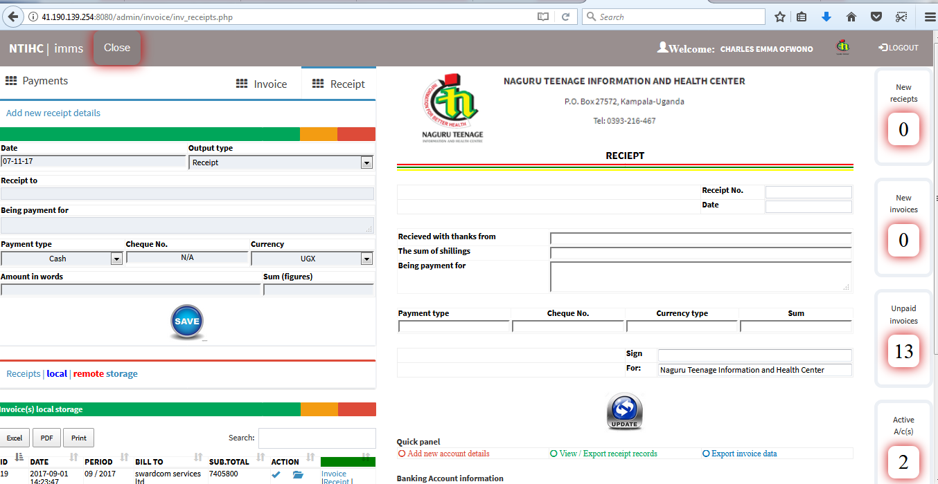

|  |  |  |  |  |  |  |  |
| --- | --- | --- | --- | --- | --- | --- | --- |
| NO | MODULE | SUB MODULE | SERVER SIDE | USER SIDE BEHAVIOUR / LINK | REPORTS | COMMENT | REQUIRE  MENTS |
| 2 | Admin module | Payments voucher |  | * http://41.190.139.254:8080/admin/pmts/pmts_mgr.php * Deployed and working, the link is under cash extension dropdown | Data tables with export buttons were created |  |  |

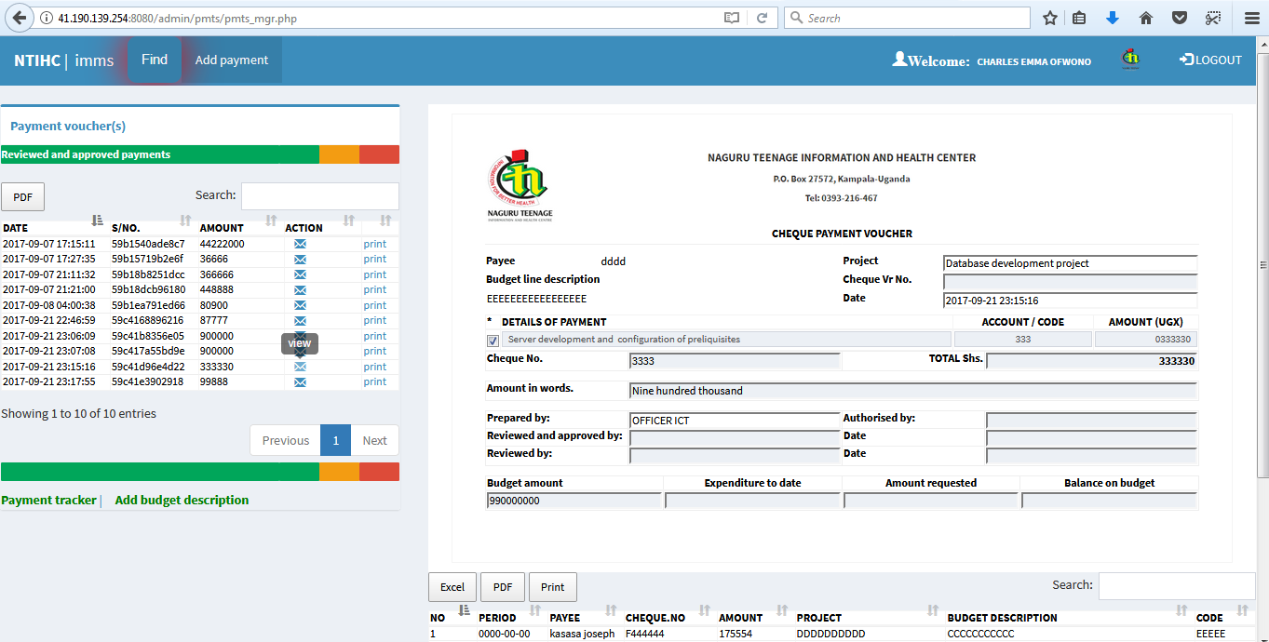

|  |  |  |  |  |  |  |  |
| --- | --- | --- | --- | --- | --- | --- | --- |
| NO | MODULE | SUB MODULE | SERVER SIDE | USER SIDE BEHAVIOUR / LINK | REPORTS | COMMENT | REQUIRE  MENTS |
| 2 | Admin module | Imprest |  | * http://41.190.139.254:8080/admin/pmts/pmts_mgr.php * Deployed and working, the link is under cash extension dropdown | Data tables with export buttons were created |  |  |

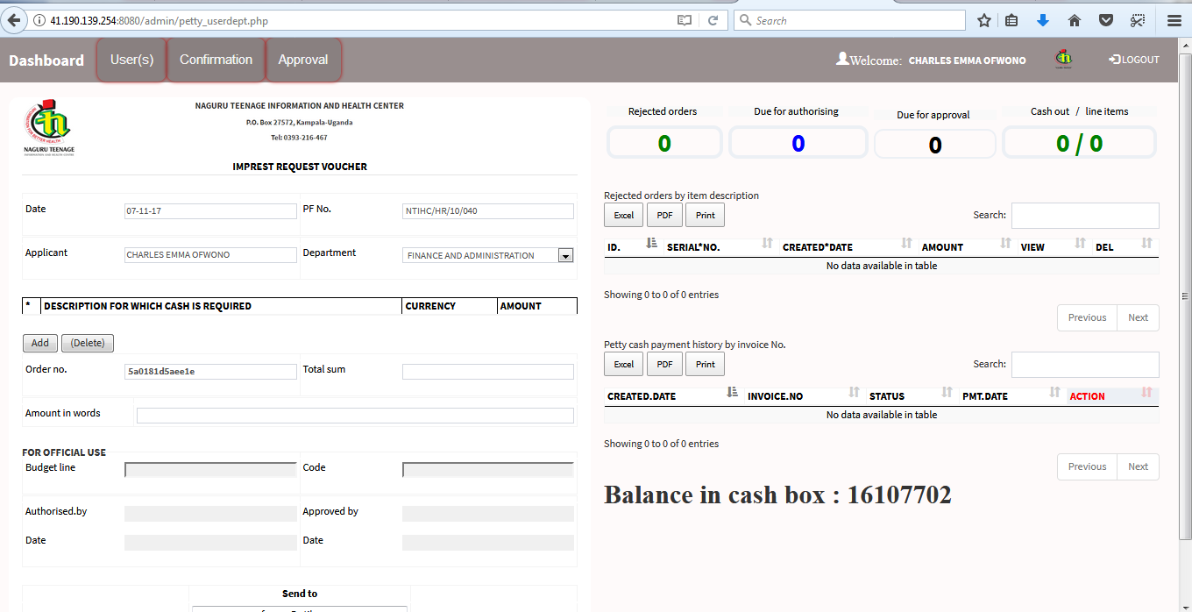

|  |  |  |  |  |  |  |  |
| --- | --- | --- | --- | --- | --- | --- | --- |
| NO | MODULE | SUB MODULE | SERVER SIDE | USER SIDE BEHAVIOUR / LINK | REPORTS | COMMENT | REQUIRE  MENTS |
| 2 | Admin module | Stores |  | <http://41.190.139.254:8080/admin/proc/stores_module.php>   * Add an edit items * Receive purchase orders and issue stock * Receive requisitions for drugs and able to issue against item description and batch number * Access to Donations is enabled * Delivery notes are auto generated where order type = facility. * Linked to assets management | Items tracker  Expiry tracker  Monthly stock report | The available data tables were created by using “left join” query structure.  Automated in phpmyadmin  Set in phpmyadmin | The developer will contact the system administrator on how to have them operational as he is experienced in setting MySQL password in unset fields. |
|  |  |  | Electronic data processing | * Verification of set phpmyadmin table behavior: * Click on store requisition label and then “Generate”. Try to type “COTRIMOXAZOLE 960MG TABS” | (iv)Donations report | Pivot tables for the above reports were created but lacks connection to MySQL. |  |
|  |  |  |  | On click, it will trigger the quantity in stock from phpmyadmin store table, |  |  |  |
|  |  |  |  | * Add quantity issued -- -- -- and then click the “add button”.   Data is submitted and stock reconciliations including expiry date tracker is updated.   * On next insert of the previously captured item, it will display the current quantity in stock less the previous quantities issued |  |  |  |

For every issuance of items, the processor is set to update the “receivables table” where item (description = description and batch number= batch number)

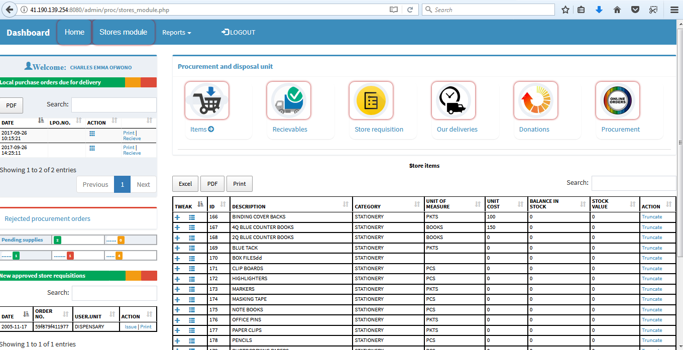

|  |  |  |  |  |  |  |  |
| --- | --- | --- | --- | --- | --- | --- | --- |
| NO | MODULE | SUB MODULE | SERVER SIDE | USER SIDE BEHAVIOUR /LINK | REPORTS | COMMENT | REQUIRE  MENTS |
| 2 | Admin module | Property management |  | <http://41.190.139.254:8080/admin/property/asset.php>  (I) Able to add and update assets | (i) Fixed assets register | Completed |  |
|  |  |  |  | (ii) Integrated with a verification launcher and on action, sets items due for verification where Asset availability status=”AVAILABLE”  (III)On the “Tweak button”, The set glyph icons alongside data rows are loops. The left glyph icon titled “verify” enables the user to  A__Verify availability of an asset.  B__Dispose an asset from the register. | (ii) Assets verification report | Completed |
|  |  |  |  |  | (iii)Others | Set by datatables |
|  |  |  |  |  |  |  |  |
|  |  |  |  |  |  |  |  |
|  |  |  |  |  |  |  |  |
|  |  |  |  |  |  |  |  |

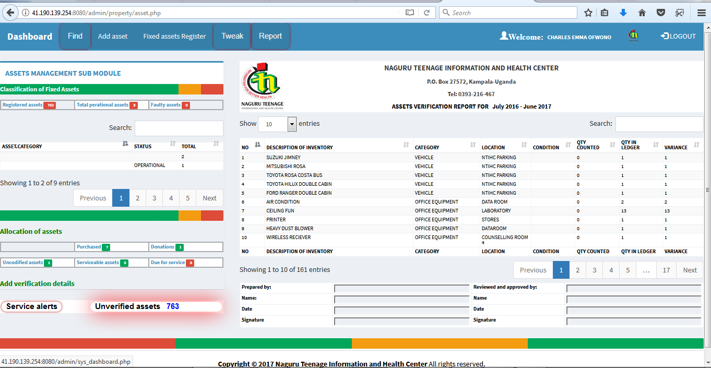

|  |  |  |  |  |  |  |  |
| --- | --- | --- | --- | --- | --- | --- | --- |
| NO | MODULE | SUB MODULE | SERVER SIDE | USER SIDE BEHAVIOUR | REPORTS | COMMENT | REQUIRE  MENTS |
| 1 | Admin module | Fleet management |  | <http://41.190.139.254:8080/admin/fleet/fuel_mgt.php> | Datatables for quick extraction of data |  |  |
|  |  |  |  | (**i**) Able to add and edit vehicle details  (**ii**) Any one can book a vehicle and the electronic processing of reservation orders up to issuance is set  (**iii**) Requisitioning of fuel and approvals is operational as guided by the manager finance.  (iv) Journey costing is set for as per single journey using mileage start and end.  (v) Log book, The design for this link enables drivers to fill in their vehicle logs information using their phones. It’s developed and deployed but its connection requires MYSQL password settings to yes. |  |  |
|  |  |  |  | (vi) Motor vehicle servicing, the dom was developed, processor / backend storage was created, The PHP page is on the server but not linked, the developer will give guidelines to the system admin on how to loop this sub child module by creating a button on the dashboard.  (vii) The fleet administrators are able to load fuel by filling the re-loading requisition form  (viii) Reconciliation of fuel loaded against fuel service provider invoice, The pivot table is not integrated. |  |  |  |
|  |  |  |  |  |  |  |  |

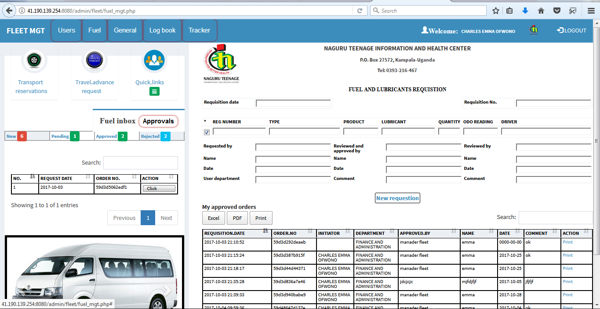

|  |  |  |  |  |  |  |  |
| --- | --- | --- | --- | --- | --- | --- | --- |
| NO | MODULE | SUB MODULE | SERVER SIDE | USER SIDE BEHAVIOUR | REPORTS | COMMENT | REQUIRE  MENTS |
| 1 | Admin module | Procurement |  | <http://41.190.139.254:8080/admin/proc/proc_pdu_user.php> |  |  |  |
|  |  |  |  | (**i**) Any one can access the procurement requisition, fill and forward for other action. On system login, everyone is able to access his/her requisition history.  (**ii** Electronic processing of requisitions, confirmation, forwarding for approval, reviewing, deleting and updating of rejected requisitions is set and operational.  (**iii**) PDU is able to receive approved orders to process procurement. | Datatables were created |  |
|  |  |  |  | (iv) Able to create local purchase order  (v) Suppliers management link is working  (vi) Able to register a contract and the tracker is active.  (vii) Under the (procmgt) tab the user can add procurement plan details for a financial year.  (viii) Reconciliation of procurement against payments-🡪Its automated just like the stores but the pivot is not linked to the user interface  The developer will communicate to the system admin about the few remaining steps to have it operational. |  |  |  |
|  |  |  |  |  |  |  |  |

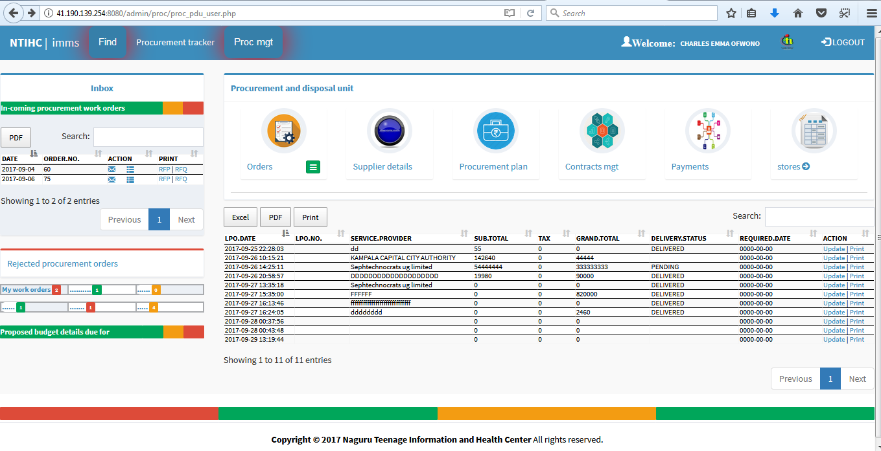

|  |  |  |  |  |  |  |
| --- | --- | --- | --- | --- | --- | --- |
| NO | MODULE | SUB MODULE | USER SIDE BEHAVIOUR | REPORTS | COMMENT | REQUIRE  MENTS |
| 1 | Admin module | Human resource mgt | <http://41.190.139.254:8080/admin/hrm_home/staffcontacts.php> |  |  |  |
|  |  |  | (**i**) Time sheet: completed  (**ii**) Staff contacts: The staff contact form was developed, its processor was deployed but the phpmyadmin table is missing.  (**iii**) Appraisal: User side navigation was completed but on the developer was unable to deploy the bank-end scripts which is a preliquisite for electronic processing of this sub modular link.    Other developed modular links includes; leave management, staff handover and exit form.  General status: The user interface is developed and accessible, server side programing was deployed on the server.  Pending works: Deployment of backend storage tables in phpmyadmin and, retrieving of data | A datatable for monthly hours worked per employee was created and working. |  |
|  |  |  |  |  |  |  |
|  |  |  |  |  |  |  |

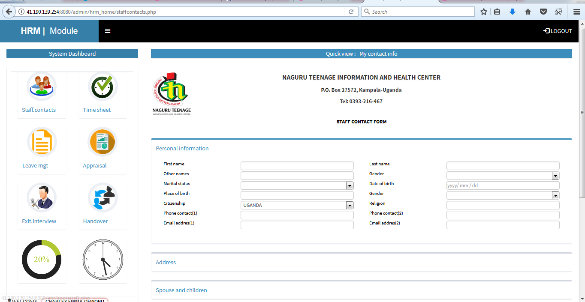

|  |  |
| --- | --- |
| Prepared by | Joseph kasasa |
| Date | 03/11/2017 |
| Contacts | 0751117650 , 0741813885 |